THE SEASONS IN ANCIENT EGYPT
Use the words in the boxes to complete the following paragraphs.
- What work was done during the Season of Inundation?
for the water sent silt season them the flooded centre because June
During the Season of Inundation _______ land near the river was ____________ . The flooding left rich soil called ___________ on the river banks. Flooding started in __________ and lasted until around October.
The ___________ in the river rose and flooded __________land because of high rainfall in the ____________ of Africa. Also snow in the highlands melted and _________ extra water into the Nile River.
During the ___________ of Inundation the peasants worked _________ the king on temples and other buildings ______________ the land was too wet for ____________ to farm.

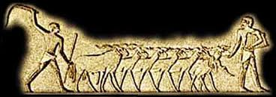
In the cultivation of grain crops, sheep played a very important role. After the sowers scattered their seed over the land, a flock of sheep was often herded out onto the land to be sure the seed was pressed down into the soil.
http://www.google.com.au/imgres?q=egypt+sheep+herding&start=221&sa=X&biw=1280&bih=843&tbm=isch&tbnid=4MhpyMxGj4fLwM:&imgrefurl=http://meieus.com/cn/cnvnh.html&docid=qoWQ7AdOymb2QM&imgurl=http://meieus.com/cn/Images/pharonic%252520sheep.jpg&w=460&h=163&ei=w86JUbbcIYaTiQfV-4DYDA&zoom=1&iact=hc&vpx=2&vpy=595&dur=38&hovh=130&hovw=368&tx=201&ty=102&page=7&tbnh=92&tbnw=260&ndsp=40&ved=1t:429,r:21,s:200,i:67

- What happened to the river and the land during the Season of Emergence?
fields land emergence to from October planted
The season when the floods began ___ fall was called the Season of __________________ . As the water went down the ___________ seemed to rise or emerge ___________ the flood. This season lasted from _______________ to February. During this season the ________ were ploughed and crops were ____________. Also, the irrigation canals were dug.
- What work was done in the Season of Drought?
for harvesting dried from
At this time the land had __________________out completely. The crops were ready ___________ harvesting. The peasants worked at _________________ the grain and separating the ears ___________ the stalks.

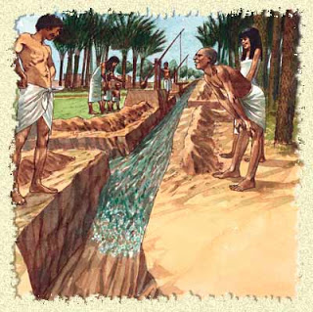
http://egy-king.blogspot.com.au/2012/07/ancient-egypt-irrigation.html
An Ancient Egyptian irrigation canal.

